|  |
| --- |
| SFU |
| STAT 485 Assignment 2 |
| Kun Yang 301178299 |

|  |
| --- |
|  |

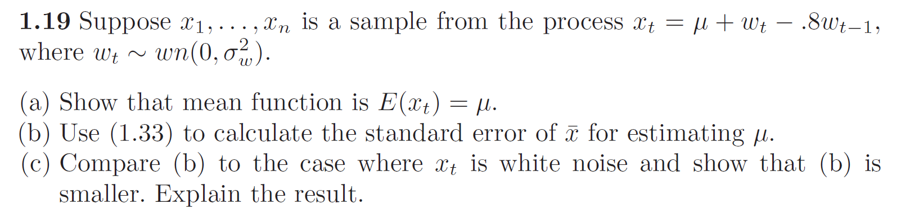

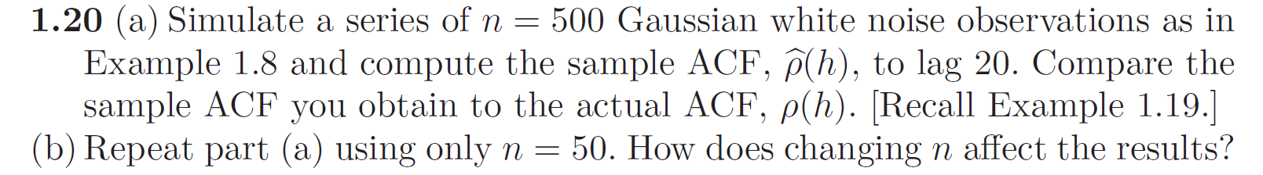

> w=rnorm(500,mean=0,sd=1)

> w=as.ts(w)

> acf.w=acf(w,lag.max=20,type="correlation")

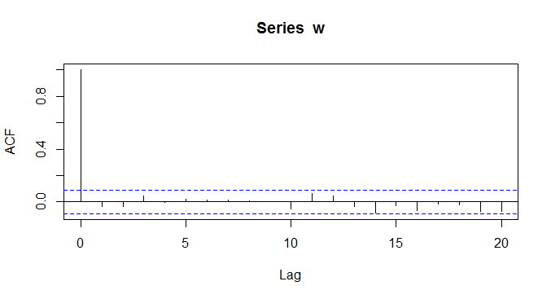

> w.small=rnorm(50,mean=0,sd=1)

> w.small=as.ts(w.small)

> acf.w.small=acf(w.small,lag.max=20,type="correlation")

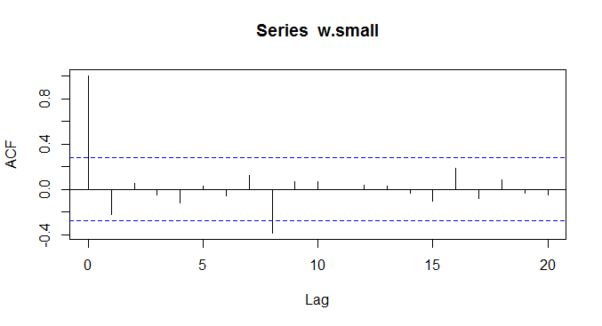

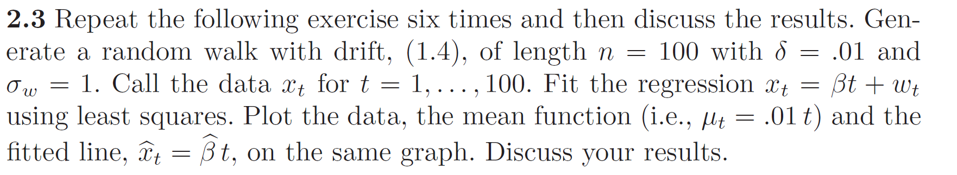

> par(mfcol = c(3,2))

> for (i in 1:6){

+ x = ts(cumsum(rnorm(100,.01,1)))

+ reg = lm(x~0+time(x), na.action=NULL)

+ plot(x)

+ lines(.01*time(x), col="red", lty="dashed")

+ abline(reg, col="blue") }

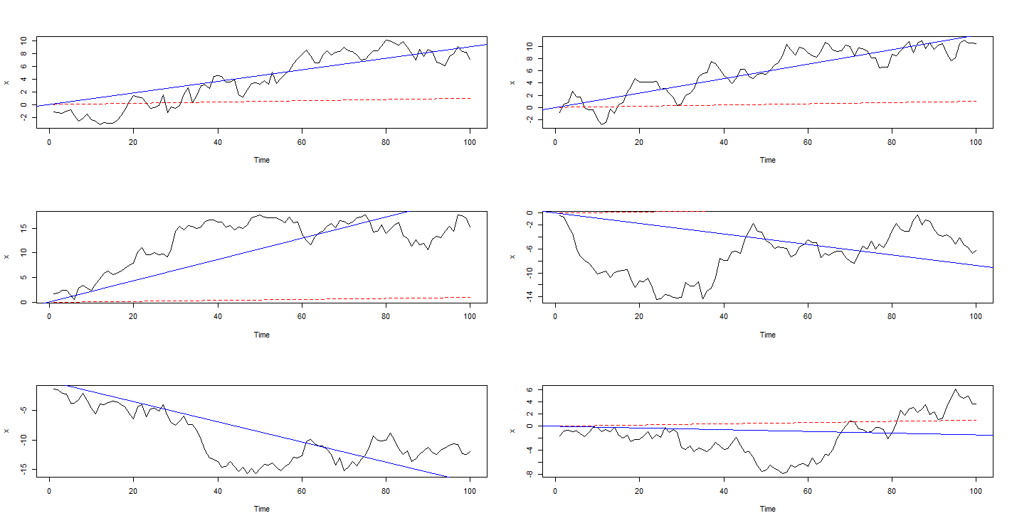

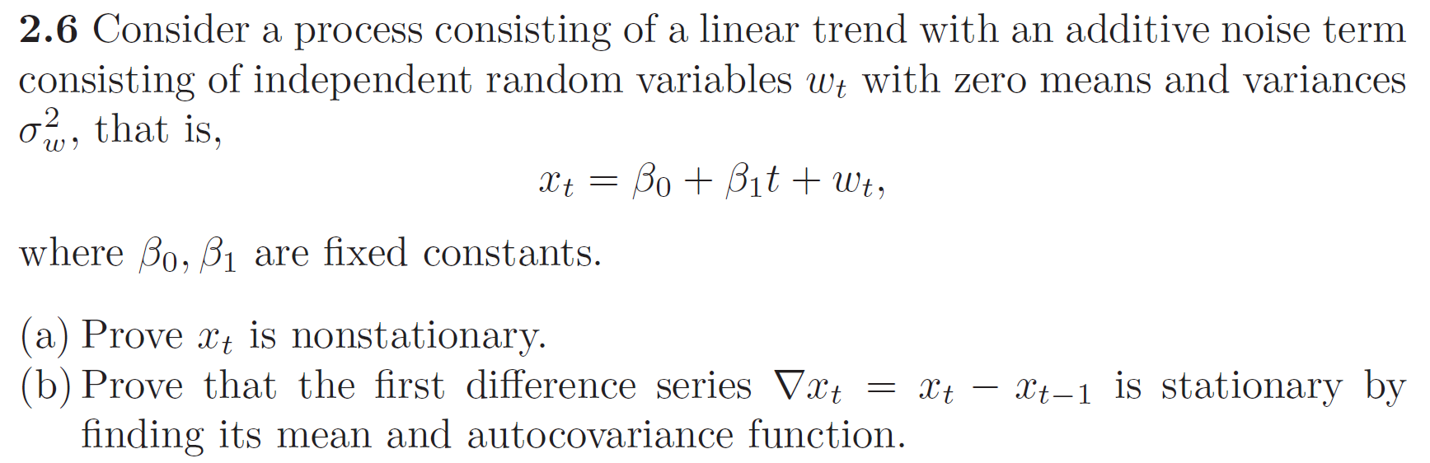



> ### Detrending

> fit = lm(gtemp~time(gtemp), na.action=NULL)

> par(mfrow=c(2,1))

> plot(resid(fit), type="o", main="detrended")

> plot(diff(gtemp), type="o", main="first difference")

> par(mfrow=c(3,1))

> acf(gtemp, 48, main="gtemp")

> acf(resid(fit), 48, main="detrended")

> acf(diff(gtemp), 48, main="first difference")

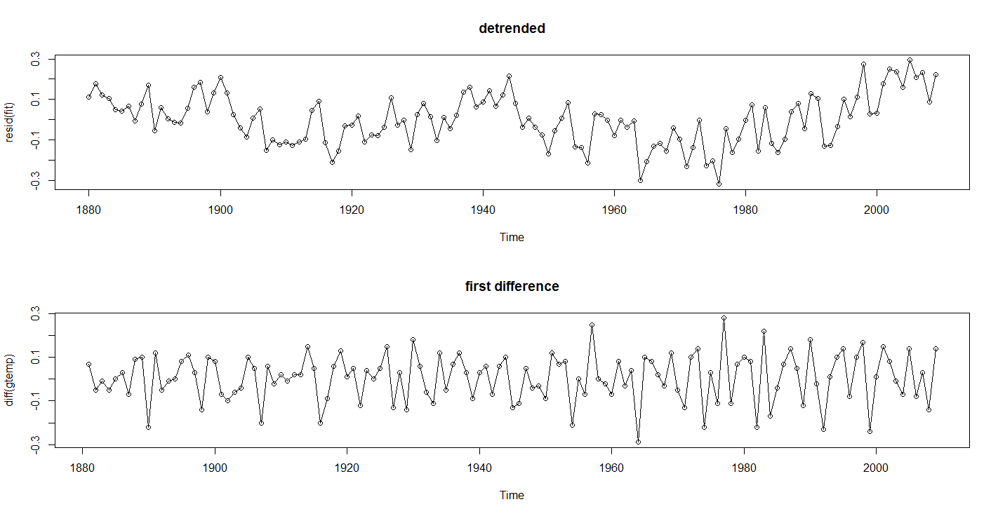

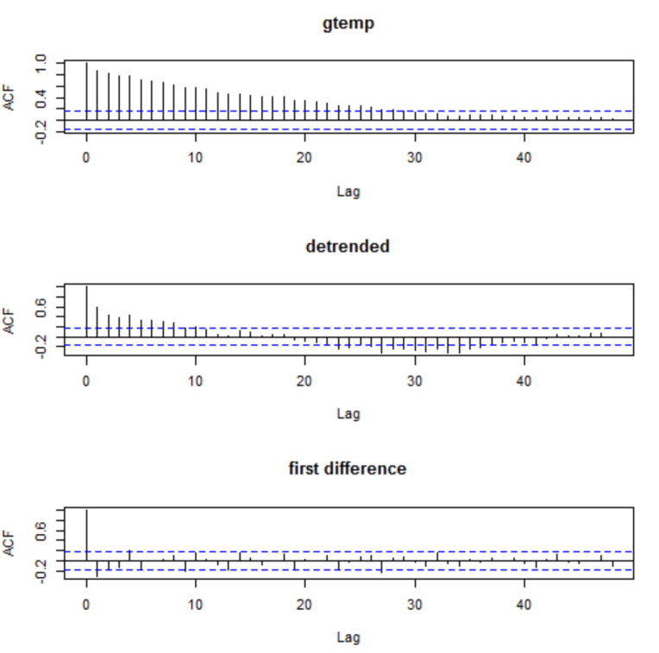

> ### moving average

> ma5=filter(gtemp, sides=2, rep(1,5)/5,method="convolution")

> ma30=filter(gtemp, sides=2, rep(1,30)/30,method="convolution")

> plot(gtemp, type="p", ylab="global temperature deviations",main="Moving Average Smoother")

> lines(ma5)

> lines(ma30,col="red",lwd=3)

